Claims Registration – feedback after changes made_15June

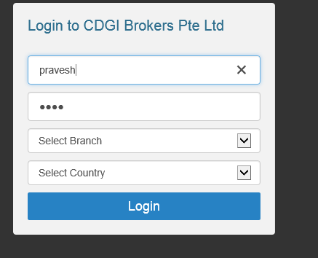

Please delete Country. User can register claims for multiple countries from a single login. In view of this function, I have moved Country selection to New Claims Registration.

The Country Code must be a unique link to identify claims belonging to each country.

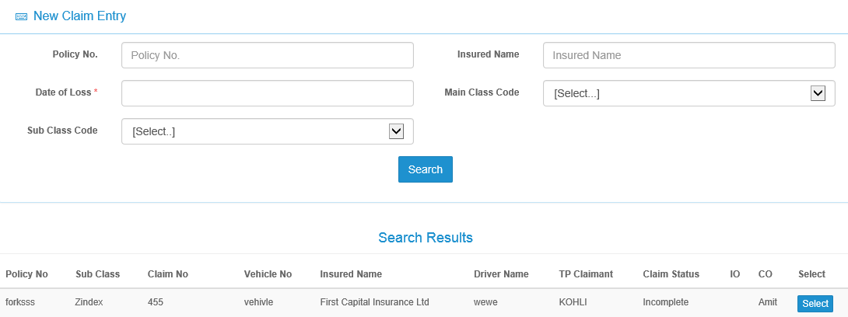

Data pull from Organization field in Accident tab

New column - Insurer

Please insert back Country.

Organization Country – drop down from Admin

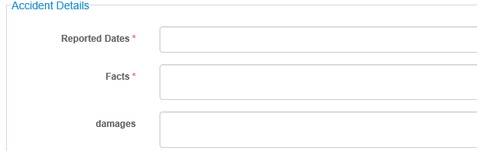

Damages

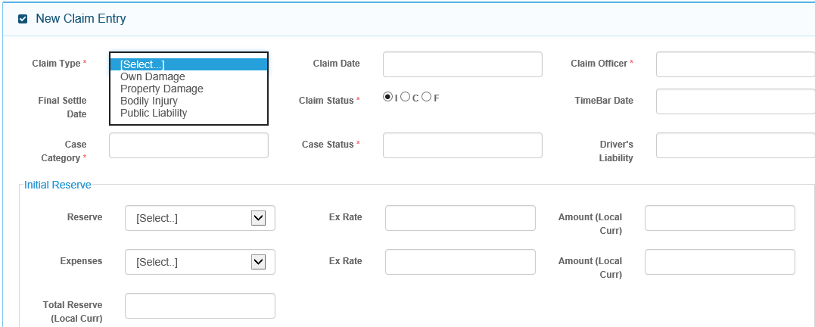

New field- Payable To – drop down from selected Adjuster/Lawyer/Surveyor/Workshop

Please reduce field length. Default to SGD

View reserve History

This is the sum of Amount Local fields. Please align it

Field to insert value. Provide 2 decimal places

As discussed, default to Own Damage

Same row as Claim Amount

Paid to Date and Balance LOG – shift down below Payable To

Amount (Local Curr)

Ex Rate

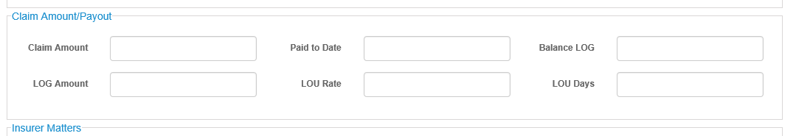

The additional fields are necessary as Payee details have to be captured to support Claim Amount payout.

View Reserve/Payment History

Currency

Please disregard my earlier comments on New Other Party. Used these feedback instead –

Other Party – this will have three sections –

1. Third Party Claimant
2. Description of Damage/Loss
3. Reserve
4. Claim Amount/Payout

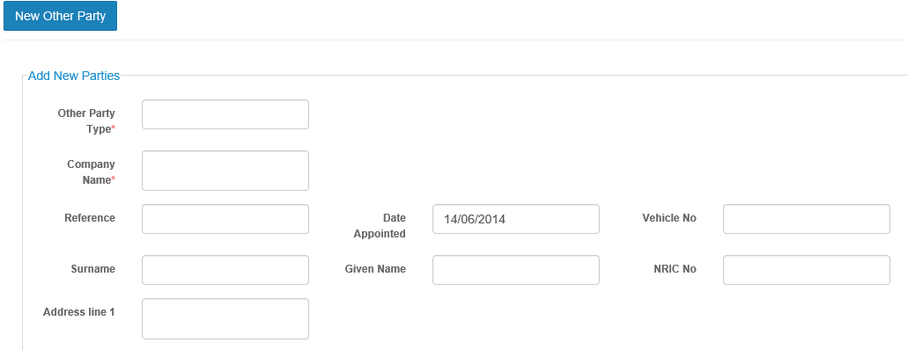

Drop down selection – Third Party Property Damage/Third Party Vehicle/Bodily injury/Public Liability

Section 1

1. If Third Party Property Damage selected, display these fields-

Claimant Name field – 150 Chars, Address Field – 200 chars, Contact Tel field, Email field

1. If Third Party Vehicle Damage selected, display these fields –

Claimant Name Field – 150 chars, NRIC/PP No. – 20 chars, Address Field – 200 chars, Contact Tel, Vehicle Regn No. – 10 alphanumeric, Vehicle Make – 30 chars, Vehicle Model – 20 chars

1. If Third Party Public Liability selected, display these fields –

Claimant Name field – 150 Chars, Address Field – 200 chars, Contact Tel field, Email field

1. If Third Party Bodily Injury selected, display tehse fields –

Claimant Name Field – 150 chars, NRIC/PP No. – 20 chars, Address Field – 200 chars, Contact Tel,

Section 2

500 chars

Description of Damage/Loss –

Third Party Workshop

Free Text

Third Party Lawyer

Free text

Third Party Adjuster

Free Text

Remarks box –

500 chars

File Attachment

Browse

Section 3

Initial Reserves – follow the same layout as in Claim Tab

Section 4

Claim Amount/Payout – follow the same layout as in Claim Tab

New Admin Master table (using Insurer master as base) –

Organization Country –

Organization Country information

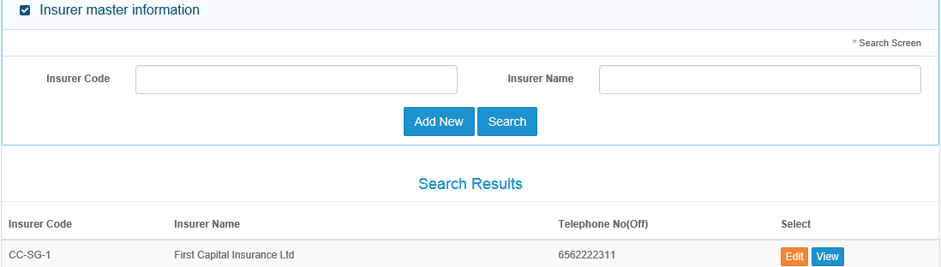

Organization Country master details

Organization Name

Country Master code

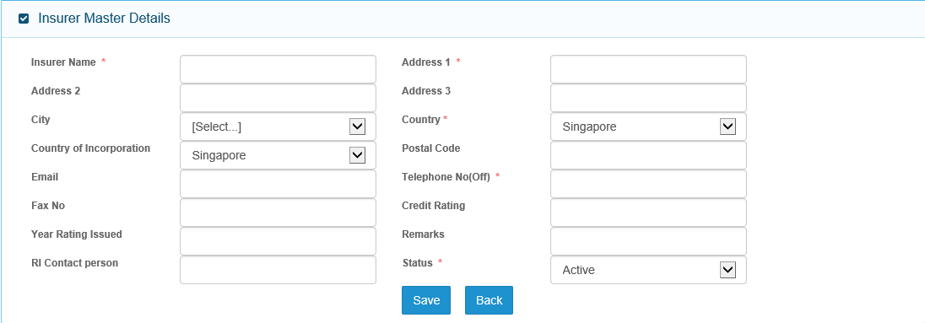

Click on Save button, Country Organization code generated – 4 digit – CZ01

Please note for User access rights to countries, please validate against this master.

Follow new address layout

Organization Name*